**TRƯỜNG THCS HUỲNH TẤN PHÁT   
 TỔ TIẾNG ANH**

**NỘI DUNG HỌC TẬP TRÊN MẠNG INTERNET CỦA HỌC SINH KHỐI 6**

**Tiết 1 : UNIT 10: STAYING HEALTHY**

**C. MY FAVOURITE FOOD**(Món ăn yêu thích của tôi) **( p112)**

1. **Vocabulary** :

|  |  |
| --- | --- |
| - carrots(n): củ cà rốt  - lettuce (n) : rau diếp  - beans (n) : quả đậu  - cabbages (n) : cải bắp  - tomatoes(n) : quả cà chua  - potatoes(n) : củ khoai tây  - peas(n) : hạt đậu hà lan  - onions(n) : củ hành  - garlic(n) : củ tỏi | - lemonade(n) : nước chanh  - iced tea (n) : trà đá  - orange juice (n) : nước cam  - milk (n) : sữa  - water (n): nước  - iced coffee (n): cà phê đá  - apple juice (n) nước táo  - soda(n) : nước soda |

**II. Grammar.**

WHAT ARE THESE/ THOSE?

THEY ARE …(beans, carrots…)

Ask and answer about your favourite food.

What is your favorite food ?

- I like pizza.

- My favorite food is pizza.

DO/ DOES + S + LIKE…?

- Yes, S + do/ does.

- No, S + don’t/ doesn’t.

Eg: What is your favourite food? - I like chicken and fish

Do you like carrot? - Yes, I do

Does your father like carrot? - No, he doesn’t.

**1. Look at the picture. Then practise.**

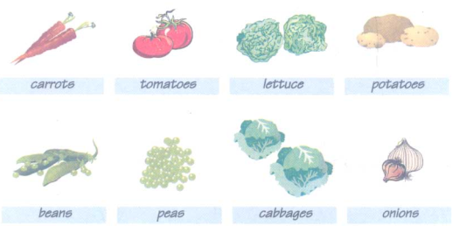

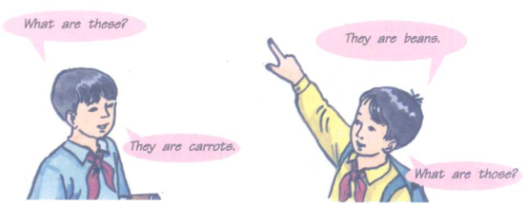

- carrots: củ cà rốt

- tomatoes: ____________________________

- lettuce: _____________________________

- potatoes: _____________________________

- beans: _________________________________

- peas: _______________________________

- cabbages: ___________________________

- onions: _____________________________

**2. Read the dialogue. Then practise .**

Nhan: What's your favorite food, Mai?  
Mai: I like fish.  
Nhan: Do you like vegetables?  
Mai: Yes, I do.  
Nhan: Do you like carrots?  
Mai: No, I don't. I like peas and beans.

**Bài 3**

**3. look at the pictures and practise.**

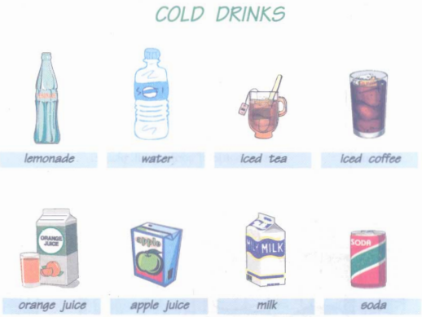

- cold drinks: _________________________

- lemonade: _________________________

- water: ____________________________

- iced tea: ___________________________

- iced coffee: _________________________

- orange juice: ________________________

- apple juice:____________________________

- milk: _________________________________

- soda: ________________________________

**4. Practise**

Do you like cold drinks?

Yes, I do.

What would you like?

I like iced tea. It's my favourite drink.

1. **Practice**
2. ***Put these words into suitable groups: food/ drink/ fruit/ vegetables/ feeling***

apple banana bean bread cabbage

Carrot chicken fish iced tea iced coffee

Meat lemonade milk apple orange juice

Onion noodles tired full thirsty

Soda hungry potatoes cold apple juice

Rice hot pea orange tomato

1. ***Supply the correct Tense of the Verbs in parentheses:***

I (like)_____ apple juice, but my sister (not, like) _______ it.

What (your father/ want) _________? - He (want)_______some lemonade.

________(you/ like) hot tea or iced tea?

Lemonade (be) _______her favourite drink. She (like) _____it very much

What (your favourite/ food) __________?

1. ***Change these sentences into negative and question.***
2. I like cold drink.
3. Lan likes Orange juice.
4. She is hungry and thirsty
5. They like iced coffee
6. There is some rice and chicken for dinner.
7. Hoa likes potatoes and carrots.
8. Ba wants some apple juice
9. Ms Huong would like some lemonade.
10. ***Make the questions with the words underlined:***

She likes tomatoes and beans very much.

I’d like some orange juice, please

Lan wants some bread and milk for breakfast.

No, there aren’t any cabbages for lunch.

These are carrots and onions.

His favourite food is rice and chicken

They are tired and hot.

No, they aren’t hungry.

1. ***Write the sentences using the cues given:***
2. There/ ten oranges / table
3. I/ rice/ chicken/ lunch
4. Apple juice/ my/ favourite drink
5. Ba/ hungry/ tired
6. Lan/ like/ tomatoes?
7. What/ you/ like/ dinner?
8. Mai/ like/ cabbages?
9. What/ matter/ you? - I/ tired

**Tiết 2 : REVISION**

**PRACTICE FOR UNIT 10**

**Chọn từ, cụm từ hoặc câu thích hợp để điền vào chỗ trống :**

1. **Cho dạng hoặc thì đúng của từ trong ngoặc :**
2. I’m …………I’d like some meat and some rice.
3. tired B. thirsty C. hungry D. full
4. How does she…………………? - She is cold.
5. feel B. like C. do D. likes
6. Are there any……………….in the fridge ?
7. meat B. apples C. water D. milk
8. What is there to……….? - There is some milk.
9. have B. drink C. eat D. watch
10. He eats an apple every morning. It’s my ………………food.
11. good B. liked C. favorite D. nice
12. Would you like some tea ? -…………………..I’m not thirsty.
13. Yes, please B. Not at all C. No, thanks. D. No, I don’t like
14. He feels sleepy. He wants ………………….to bed.
15. going B. go C. to go D. goes
16. What are these ?-……………………..are potatoes.
17. It B. They C. These D. Those
18. **Đặt câu hỏi cho các từ được gạch dưới :**
19. He feels hot.
20. I’d like some meat and vegetables.
21. No, I don’t like noodles.
22. My sister wants hot milk.
23. His favorite food is chicken.
24. There is some fish and some rice for lunch.
25. Yes, there are some bananas.
26. He likes iced coffee.
27. We often have breakfast at 7.30.
28. There is some orange juice for drink.
29. **Hoàn thành đoạn văn sau với các từ cho sẵn :**

|  |
| --- |
| ***big drink at has food likes some so dinner*** |

Minh has breakfast (1)……….6:30. He (2)………..bread and butter for his breakfast. He (3)…………..some hot milk. It’s his favorite drink. At 11:30 he has……..a lunch with chicken, vegetables and rice. He (5)……..chicken. It’s his favorite (6)…………(7)…………….is at 6 : 30 in the evening. He doesn’t like vegetables for dinner, (8)………….he has some fish, soup, and rice. He drinks (9)…………orange juice for dinner.

1. **Sắp xếp câu theo trật tự đúng.**
2. fruit**/** any/ there/ is/ bananas/ some/ but/ there/ aren’t.

….…………………………………………………………………………………………

1. Tired/ down/ he/ like/ feel/ and/ would/ sit/ to/ he.

….…………………………………………………………………………………………

1. Like/ chicken/ eggs/ the/ bread/ and/ breakfast/ for/ their.

….…………………………………………………………………………………………

1. Favorite/ your/ what/ food/ is/ father’s ?

….…………………………………………………………………………………………

1. Likes/ vegetables/but/ doesn’t/ Nhan/ he/ likes/ beans.

….…………………………………………………………………………………………

1. Not/ I/ hungry/wouldn’t/ am/ so/ like/ sandwich/ a/ I.

….…………………………………………………………………………………………

**Tiết 3**

**UNIT 11: WHAT DO YOU EAT?**

1. **Vocabulary.**

- store /stɔ:/ (n): cửa hàng

- storekeeper = shopkeeper /'stɔ:,ki:pə/ (n): chủ cửa hàng

- salesgirl /'seizgə:l/ (n): cô bán hàng

- bottle /'bɔtl/ (n): chai

- oil /ɔil/ (n): dầu

- cooking oil /'kukiɳ ɔil/ (n): dầu ăn

- chocolate /'tʃɔkəlit/ (n): sô-cô-la

- biscuit /'biskit/ (n): bánh quy

- cookie /'kuki/ (n): bánh quy

- can /kæn/ (n): hộp

- tin /tin/ (n): hộp

- bar /bɑ:/ (n): thỏi, thanh

- packet /'pækit/ (n): gói nhỏ, hộp nhỏ

- dozen /'dʌzn/ (n): một tá (= 12 cái)

- gram /græm/ (n): 1 gam

- kilogram (kilo) /kiləgræm/ (n): ki-lô-gam

- half /hɑ:f/ (n): một nửa, nửa

- egg /eg/ (n): trứng

- soap /su:p/ (n): xà phòng, xà bông

- tube /tju:b/ (n): ống

- toothpaste /'tu:θpeist/ (n): kem đánh răng

- list /list/ (n): danh sách

- shopping list /'ʃɔpiɳ list/ (n): danh sách vật mua sắm

- need /ni:d/ (v): cần

- want /wɔnt/ (v): muốn

- lemon /'lemən/ (n): chanh

- ice-cream /aɪs kriːm/ (n): kem (cà rem)

- sandwich /'sænwiʤ/ (n): bánh săngwich

- cake /keik/ (n): bánh ngọt

- fried /fraid/ (p.p): được chiên, được rán

- delicious /di'liʃəs/ (n): thơm tho, ngon

- wine /wain/ (n): rượu

1. **GRAMMAR**
2. **HOW MUCH / HOW MANY**

**How much + uncountable noun + do/ does + S + V (bare) ?**

**How many + countable noun + do/ does + S + V (bare) ?**

e.g. How many eggs do you want?- I want four eggs.

How much rice does your mother want? – She wants a kilo of rice.

***How many : dùng để hỏi cho danh từ đếm được số nhiều.***

***How much : dùng để hỏi cho danh từ không đếm được.***

1. **Want: muốn / need : cần**

**S + want(s) / need(s) + Noun/ To V**

e.g. I want a new dress.

She wants to go home.

1. **HOW MUCH ( hỏi giá tiền)**

**Question : How much + is/ are + S ?**

**How much + do/ does + S + cost?**

e.g. How much is this shirt?

How much does this shirt cost?

- It’s eighty thousand dong.

**Bài 1**

**1 a) Practise**

Storekeeper: Can I help you?  
Vui: Yes. A bottle of cooking oil, please.  
Storekeeper: Here you are.  
Vui: Thank you.

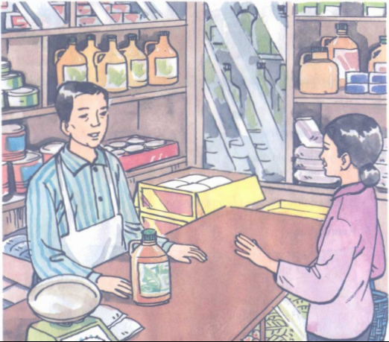

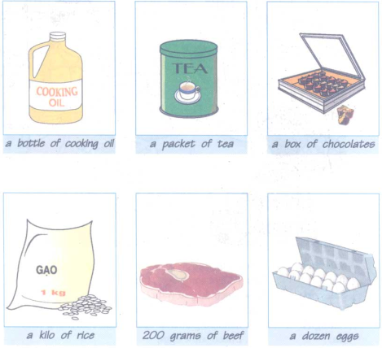

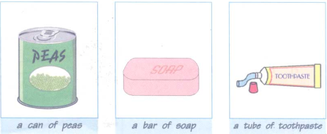

- a bottle of cooking oil: ________________________

- a packet of tea: ______________________________

- a box of chocolate: ___________________________

- a kilo of rice: ______________________________

- 200 grams of beef: __________________________

- a dozen of eggs: ___________________________

- a can of peas: ____________________________

- a bar of soap: ______________________________

- a tube of toothpaste: _______________________

**Bài 2**

**2. Read and answer the questions.**

Salesgirl: Can I help you?  
Ba: Yes. I'd like some beef, please.  
Salesgirl: How much do you want?  
Ba: Two hundred grams, please.  
Salesgirl: Two hundred grams of beef. Is there anything else?  
Ba: Yes. I need some eggs.  
Salesgirl: How many do you want?  
Ba: A dozen, please.

**Questions:**

a) Where is Ba?_________________________  
b) What does he want?_________________________  
c) How much beef does he want?_________________________  
d) How many eggs does he want?______________________________

**Bài 3**

**Read. Then write the shopping list in your exercise book.**

*(Đọc. Sau đó viết danh sách những vật mua sắm vào tập bài tập của em.)*

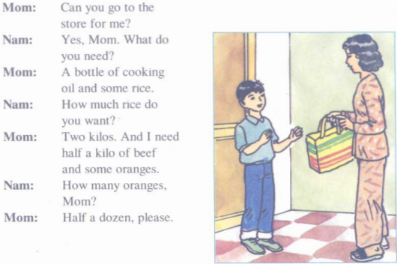

**PRACTICE**

***I, Ghép các từ ở cột A với các từ ở cột B***

|  |  |
| --- | --- |
| A  a bar  a can  a tube  a dozen  a bottle | B  of toothpaste  of eggs  of cooking oil  of soap  of peas |

***II, Hoàn tất đoại hội thoại sau, sau đó trả lời câu hỏi***

|  |  |
| --- | --- |
| Salesgirl:  Thu:  Salesgirl:  Thu:  Salesgirl: | Can I __________ you?  Yes, __________ a sandwich and a glass of lemon juice, please.  __________?  Thanks, __________ are they?  Two thousand five hundred dong……. Thank you. |

1. What does Thu want?_______________________________
2. How many sandwiches does she want?____________________________
3. How much lemon juice does she want?______________________________
4. How much are they?_____________________________________
5. Where is she?________________________________________

***III, Đặt câu hỏi và trả lời về giá của một món ăn theo gợi ý***

1. a fried rice/ 2.500d. -> *How much is a fried rice?*

*It’s 2 500 d*

1. a bowl of noodles/ 3.000 d _________________________________
2. an ice-cream/ 2.000 d _________________________________
3. a cake/ 1.000 d ________________________________
4. a sandwich/ 500 d___________________________________
5. a glass of orange juice/ 2.500 d ____________________________
6. a bottle of cooking oil/ 10 .000 d _____________________________
7. a kilo of carrot/ 3. 000 d __________________________________
8. a can of peas/ 5.000 d ________________________________
9. a bar of soap/ 6. 000 d ____________________________________

***IV, Chọn từ đúng trong ngoặc***

1. She __________ (want, don’t want, wants) some vegetables.
2. We don’t want __________ (some, any, a) oil.
3. How __________(much, many, about) kilos of meat does she want?
4. Her sister doesn’t want __________ (some, any, a) coffee.
5. __________(How many, How much) rice does she want?
6. My mother __________ (cook, cooking, cooks) the meals every day.
7. They need __________ (a, some, any) soda.
8. How __________ (much, many, about) fish does your mother want?
9. How __________ (much, many, about) are these eggs?
10. Do you have __________ (a, an, any) bananas?

***V, Sắp xếp các từ dưới đây thành câu***

1. some/ want/ milk/ these/ students.
2. a/ of/ likes/ orange/ juice/ Mai/ glass.
3. at/ 7 o’clock/ Ba/ breakfast/ morning/ every.
4. for/ have/ lunch/ what/ you/ do?
5. any/ banans/ but/ some/ I have/ I/ don’t/ have/ oranges.
6. like/ you/ do/ noodles?
7. Lan/ chicken/ or/ like/ does/ meat?
8. he/ much/ how/ does/ have/ homework?
9. isn’t short/ hair/ his.
10. traveling/ she/ bus/ by/ is/ now.

***VI, Hoàn tất các câu sau***

1. How __________bananas are there?
2. There __________twelve bananas.
3. Are there __________onions on the table? –No, There __________
4. __________I help you?
5. __________else?
6. Yes, I need ____________ eggs.
7. How __________rice do you want?
8. Mrs Tu needs __________beef.
9. She __________tall. She is short.
10. How __________is this book? 500 dong.

***VII, Dùng (do, does, don’t, doesn’t) điền vào chỗ trống***

1. I want some rice, but my friend __________.
2. Nam doesn’t like bananas, but I __________.
3. They don’t like chicken, but their mother __________.
4. My father likes coffee, but my mother __________.
5. We don’t want brown pencils, but they __________.

**HƯỚNG DẪN SỬA BÀI**

**UNIT 10 C**

**1. Look at the picture. Then practise.**





- carrots: củ cà rốt

- tomatoes: cà chua

- lettuce: cải mâm xôi

- potatoes: khoai tây

- beans: đậu

- peas: hạt đậu

- cabbages: bắp cải

- onions: củ hành

A: Những cái này là gì?

B: Chúng là hạt đậu. Những cái kia là gì?

A: Chúng là cù cải đỏ (cà rốt).

**2. Read the dialogue. Then practise .**

Nhan: What's your favorite food, Mai?  
Mai: I like fish.  
Nhan: Do you like vegetables?  
Mai: Yes, I do.  
Nhan: Do you like carrots?  
Mai: No, I don't. I like peas and beans.

**Tạm dịch:**

Nhân: Mai, thức ăn ưa thích của bạn là gì?

Mai: Tôi thích cá.

Nhân: Bạn thích rau củ không?

Mai: Vâng, tôi thích.

Nhân: Bạn thich cà rốt không?

Mai: Không, tôi không thích. Tôi thích đậu hạt to và đậu hạt nhỏ.

**Hướng dẫn giải:**

Ba: What’s your favorite food, Tan?

Tan: I like fish.

Ba: Do you like chicken?

Tan: No, I don’t like it.

Ba: Do you like fruit?

Tan: Yes, I do. I like bananas.

Ba: Do you like vegetables?

Tan: Yes, I do. I like lettuce and tomatoes. What about you?

Ba: Me? I like peas, carrots and tomatoes.

**Tạm dịch:**

Ba: Món ăn yêu thích của bạn là gì, Tân?

Tân: Tôi thích cá.

Ba: Bạn có thích gà không?

Tân: Không, tôi không thích.

Ba: Bạn có thích trái cây không?

Tân: Vâng, tôi có. Tôi thích chuối.

Ba: Bạn có thích rau không?

Tân: Vâng, tôi có. Tôi thích rau diếp và cà chua. Thế còn bạn?

Ba:  Mình á?  Tôi thích đậu Hà Lan, cà rốt và cà chua.

**Bài 3**

**3. look at the pictures and practise.**



- cold drinks: thức uống lạnh

- lemonade: nước chanh

- water: nước

- iced tea: trà đá

- iced coffee: cà phê đá

- orange juice: nước cam vắt

- apple juice: nước táo ép

- milk: sữa

- soda: nước có gas

**4. Practise**

Do you like cold drinks?

Yes, I do.

What would you like?

I like iced tea. It's my favourite drink.

**Tạm dịch:**

- Bạn thích thức uống lạnh không?

- Có.

- Bạn thích thức uống gỉ?

*-*Tôi thích trà đá. Nó là thức uống ưa thích của tôi.

**UNIT 11A**

**Bài 1**

**1 a) Practise**

Storekeeper: Can I help you?  
Vui: Yes. A bottle of cooking oil, please.  
Storekeeper: Here you are.  
Vui: Thank you.



**b. Look at the picture and practise**

**

**

**a)**

**Tạm dịch:**

Chủ tiệm : Cô cần gì?

Vui : Vâng. Vui lòng cho tôi một chai dầu ăn.

Chủ tiệm : (Thưa cô) Đây.

Vui : Cám ơn.

**b)**

A: Can I help you?

B: Yes, a packet of tea, please.

A: Here you are.

B: Thank you.

C: Can I help you?

D: Yes, a tube of toothpaste, please.

C: Here you are.

D: Thank you.

**Tạm dịch:**

- a bottle of cooking oil: một chai dầu ăn

- a packet of tea: một gói trà

- a box of chocolate: một hộp sô-cô-la

- a kilo of rice: một kg gạo

- 200 grams of beef: 200g thịt bò

- a dozen of eggs: 1 tá trừng

- a can of peas: 1 lon đậu Hà Lan

- a bar of soap: 1 bánh xà phòng

- a tube of toothpaste: 1 tuýp kem đánh răng

A: Tôi có thể giúp gì cho bà?  
  
B: Vâng, một gói trà, làm ơn.  
  
A: Đây thưa bà.  
  
B: Cảm ơn.

***

C: Tôi có thể giúp gì cho ngài?  
  
D: Vâng, một cái ống kem đánh răng.  
  
C: Đây thưa ông.  
  
D: Cảm ơn.

**Bài 2**

**2. Read and answer the questions.**

Salesgirl: Can I help you?  
Ba: Yes. I'd like some beef, please.  
Salesgirl: How much do you want?  
Ba: Two hundred grams, please.  
Salesgirl: Two hundred grams of beef. Is there anything else?  
Ba: Yes. I need some eggs.  
Salesgirl: How many do you want?  
Ba: A dozen, please.

Questions:

a) Where is Ba?  
b) What does he want?  
c) How much beef does he want?  
d) How many eggs does he want?

**Lời giải chi tiết:**

**Hướng dẫn giải:**

a. He is at a store.

b. He wants some beef and some eggs.

c. He wants two hundred grams of beef.

d. He wants a dozen eggs.

**Tạm dịch:**

a) Ba đang ở đâu? -> Anh ấy đang ở một cửa hàng.

b) Anh ấy muốn gì? -> Anh ấy muốn một ít thịt bò và 1 ít trứng.

c) Anh ấy muốn bao nhiêu thịt bò? -> 200g.

d) Anh ấy muốn bao nhiêu trừng? -> 1 tá.

**Tạm dịch bài hội thoại:**

Cô bán hàng: Cô có thể giúp gì cho cháu?

Ba: Vâng. Cháu muốn một ít thịt bò ạ.

Cô bán hàng: Cháu muốn bao nhiêu?

Ba: Vui lòng cho cháu hai trăm gram.

Cô bán hàng: Hai trăm gram thịt bò. Còn gì nữa không?

Ba: Có. Cháu cần một ít trứng.

Cô bán hàng: Cháu muốn bao nhiêu?

Ba: Cho một tá ạ.

**Bài 3**

**Read. Then write the shopping list in your exercise book.**

*(Đọc. Sau đó viết danh sách những vật mua sắm vào tập bài tập của em.)*

**

**Hướng dẫn giải:**

SHOPPING LIST:

A bottle of cooking oil

2 kilos of rice

Half a kilo of beef

Half a dozen oranges

**Tạm dịch:**

Mẹ: Con đi ra tiệm giúp mẹ nhé?

Nam: Vâng thưa mẹ. Mẹ cần gì ạ?

Mẹ : Một chai dầu ăn và một ít gạo.

Nam : Mẹ muốn bao nhiêu gạo?

Mẹ : Hai kí. Và mẹ cần nửa kí thịt bò và vài trái cam.

Nam : Mẹ cần bao nhiêu cam?

Mẹ : Nửa tá nhé con.

***

Danh sách cần mua:

1 chai dầu ăn

2 kg gạo

Nửa kg thịt bò

Nửa tá cam